**Restaurant Management System**

**Others part & Overall All Code**

**ID:232-35-100**

**Final Code:**

#include <stdio.h>

#include <stdlib.h>

#include <stdbool.h>

#include <string.h>

#define MAX_MENU_ITEMS 100

#define MENU_FILE "menu.txt"

#define ORDER_FILE "orders.txt"

#define USERS_FILE "users.txt"

// ANSI color codes

#define COLOR_RESET "\033[0m"

#define COLOR_RED "\033[31m"

#define COLOR_GREEN "\033[32m"

#define COLOR_YELLOW "\033[33m"

#define COLOR_BLUE "\033[34m"

#define COLOR_MAGENTA "\033[35m"

#define COLOR_CYAN "\033[36m"

#define COLOR_WHITE "\033[37m"

// Structure to represent a menu item

typedef struct {

    int id;

    char name[100];

    float price;

} MenuItem;

typedef struct {

    int orderId;

    char customerName[100];

    char itemName[100];

    int quantity;

    float itemPrice;

    float totalCost;

    char paymentMethod[20];

} Order;

// Global variable to keep track of next available item ID

int nextItemId = 1;

char loggedInUser[50];

// Function prototypes

void displayMainMenu();

void login();

void registerUser();

bool authenticate(const char username[], const char password[]);

void hidePassword(char *password);

void displayAdminMenu();

void displayCustomerMenu();

void displayStaffMenu();

void addMenuItem();

void removeMenuItem();

void updateMenuItem();

void displayMenu();

void placeOrder();

void viewOrderHistory();

void generateInvoice(Order orders[], int orderCount);

void choosePaymentMethod(char paymentMethod[], float grandTotal);

void terminateProgram();

void printCentered(const char *text, const char *color);

void printBordered(const char *text, const char *color, int width);

int main() {

    FILE *menuFile = fopen(MENU_FILE, "r");

    if (menuFile != NULL) {

        MenuItem item;

        char line[150];

        while (fgets(line, sizeof(line), menuFile)) {

            sscanf(line, "%d|%99[^|]|%f", &item.id, item.name, &item.price);

            if (item.id >= nextItemId) {

                nextItemId = item.id + 1; // Set nextItemId to the next available ID

            }

        }

        fclose(menuFile);

    }

    displayMainMenu();

    return 0;

}

// Function to print centered text with color

void printCentered(const char *text, const char *color) {

    int width = 80; // Assuming console width is 80 characters

    int len = strlen(text);

    int mid = (width - len) / 2;

    for (int i = 0; i < mid; i++) {

        printf(" ");

    }

    printf("%s%s%s\n", color, text, COLOR_RESET);

}

// Function to print bordered and centered text with color

void printBordered(const char *text, const char *color, int width) {

    int len = strlen(text);

    int mid = (width - len - 2) / 2; // -2 for border space

    printf("%s", color);

    for (int i = 0; i < width; i++) {

        printf("=");

    }

    printf("\n|");

    for (int i = 0; i < mid; i++) {

        printf(" ");

    }

    printf("%s", text);

    for (int i = 0; i < width - len - mid - 2; i++) {

        printf(" ");

    }

    printf("|\n");

    for (int i = 0; i < width; i++) {

        printf("=");

    }

    printf("%s\n", COLOR_RESET);

}

// Function to display the main menu

void displayMainMenu() {

    int choice;

    do {

        printf("\n");

        printBordered("Welcome to Restaurant Management System", COLOR_GREEN, 80);

        printf("\n");

        printCentered("1.Login", COLOR_CYAN);

        printCentered("2.Register", COLOR_CYAN);

        printCentered("3.Exit", COLOR_CYAN);

        printf("\n");

        printCentered("Enter your choice: ", COLOR_WHITE);

        scanf("%d", &choice);

        clearScreen();

        switch (choice) {

            case 1:

                login();

                break;

            case 2:

                registerUser();

                break;

            case 3:

                terminateProgram();

                break;

            default:

                printCentered("Invalid choice. Please try again.", COLOR_RED);

                break;

        }

    } while (1);

}

void clearScreen()

{

    system("cls");

}

void hidePassword(char *password) {

    int i = 0;

    char ch;

    while ((ch = getch()) != '\r' && i < 49) { // Enter key is '\r' in Windows

        if (ch == '\b' && i > 0) { // Handle backspace

            printf("\b \b");

            i--;

        } else if (ch != '\b') {

            printf("*");

            password[i++] = ch;

        }

    }

    password[i] = '\0';

    printf("\n");

}

// Function to login user

void login() {

    char username[50], password[50];

    clearScreen();

    printf("\nEnter username: ");

    scanf("%s", username);

    printf("Enter password: ");

    hidePassword(password);

    // Check if Admin is logging in

    if (strcmp(username, "Sindid") == 0 && strcmp(password, "123") == 0) {

        strcpy(loggedInUser, username); // Store logged-in username

        printf("\nLogin successful! Welcome Sir, %s.\n", loggedInUser);

        displayAdminMenu();

        return;

    }

    // If not Admin, check authentication for Customers/Staff

    if (authenticate(username, password)) {

        strcpy(loggedInUser, username); // Store logged-in username

        printf("\nLogin successful! Welcome, %s.\n", loggedInUser);

        // Determine user role and display respective menu

        char role[20];

        FILE *userFile = fopen(USERS_FILE, "r");

        while (fscanf(userFile, "%s %s %s", username, password, role) == 3) {

            if (strcmp(username, loggedInUser) == 0) {

                fclose(userFile);

                if (strcmp(role, "Customer") == 0) {

                    displayCustomerMenu();

                } else if (strcmp(role, "Staff") == 0) {

                    displayStaffMenu();

                }

                return;

            }

        }

        fclose(userFile);

    } else {

        printf("\nInvalid username or password!\n");

    }

}

// Function to register a new user (Customer/Staff)

void registerUser() {

    char username[50], password[50], role[20];

    clearScreen();

    printf("\nEnter username: ");

    scanf("%s", username);

    // Prevent registration of Admin username

    if (strcmp(username, "admin") == 0) {

        printf("\nError: 'admin' is reserved for the Admin and cannot be used.\n");

        return;

    }

    printf("Enter password: ");

    hidePassword(password);

    printf("Enter role (Customer/Staff): ");

    scanf("%s", role);

    // Validate role

    if (strcmp(role, "Customer") != 0 && strcmp(role, "Staff") != 0) {

        printf("\nInvalid role. Please enter either 'Customer' or 'Staff'.\n");

        return;

    }

    // Save the new user to the file

    FILE *userFile = fopen(USERS_FILE, "a");

    if (userFile == NULL) {

        printf("Error opening users file.\n");

        return;

    }

    fprintf(userFile, "%s %s %s\n", username, password, role);

    fclose(userFile);

    printf("\nRegistration successful!\n");

}

// Function to authenticate user credentials

bool authenticate(const char username[], const char password[]) {

    char storedUsername[50], storedPassword[50], role[20];

    FILE *userFile = fopen(USERS_FILE, "r");

    if (userFile == NULL) {

        printf("Error opening users file.\n");

        return false;

    }

    while (fscanf(userFile, "%s %s %s", storedUsername, storedPassword, role) == 3) {

        if (strcmp(storedUsername, username) == 0 && strcmp(storedPassword, password) == 0) {

            fclose(userFile);

            return true;

        }

    }

    fclose(userFile);

    return false;

}

// Function to display the admin menu

void displayAdminMenu() {

    int choice;

    do {

        printf("\n");

        printBordered("Admin Menu", COLOR_BLUE, 80);

        printf("\n");

        printCentered("1. Add Menu Item", COLOR_CYAN);

        printCentered("2. Remove Menu Item", COLOR_CYAN);

        printCentered("3. Update Menu Item", COLOR_CYAN);

        printCentered("4. Display Menu", COLOR_CYAN);

        printCentered("0. Logout", COLOR_CYAN);

        printf("\n");

        printCentered("Enter your choice: ", COLOR_WHITE);

        scanf("%d", &choice);

        clearScreen();

        switch (choice) {

            case 1:

                addMenuItem();

                break;

            case 2:

                removeMenuItem();

                break;

            case 3:

                updateMenuItem();

                break;

            case 4:

                displayMenu();

                break;

            case 0:

                strcpy(loggedInUser, ""); // Clear logged-in username

                displayMainMenu();

                return;

            default:

                printCentered("Invalid choice. Please try again.", COLOR_RED);

                break;

        }

    } while (1);

}

// Function to display the customer menu

void displayCustomerMenu() {

    int choice;

    do {

        printf("\n");

        printBordered("Customer Menu", COLOR_BLUE, 80);

        printf("\n");

        printCentered("1. Place Order", COLOR_CYAN);

        printCentered("2. View Order History", COLOR_CYAN);

        printCentered("3. Display Menu", COLOR_CYAN);

        printCentered("0. Logout", COLOR_CYAN);

        printf("\n");

        printCentered("Enter your choice: ", COLOR_WHITE);

        scanf("%d", &choice);

        clearScreen();

        switch (choice) {

            case 1:

                placeOrder();

                break;

            case 2:

                viewOrderHistory();

                break;

            case 3:

                displayMenu();

                break;

            case 0:

                strcpy(loggedInUser, ""); // Clear logged-in username

                displayMainMenu();

                return;

            default:

                printCentered("Invalid choice. Please try again.", COLOR_RED);

                break;

        }

    } while (1);

}

void displayStaffMenu() {

    int choice;

    do {

        printf("\n");

        printBordered("Staff Menu", COLOR_BLUE, 80);

        printf("\n");

        printCentered("1. View Order History", COLOR_CYAN);

        printCentered("2. Display Menu", COLOR_CYAN);

        printCentered("0. Logout", COLOR_CYAN);

        printf("\n");

        printCentered("Enter your choice: ", COLOR_WHITE);

        scanf("%d", &choice);

        clearScreen();

        switch (choice) {

            case 1:

                viewOrderHistory();

                break;

            case 2:

                displayMenu();

                break;

            case 0:

                strcpy(loggedInUser, ""); // Clear logged-in username

                displayMainMenu();

                return;

            default:

                printCentered("Invalid choice. Please try again.", COLOR_RED);

                break;

        }

    } while (1);

}

// Function to add a new menu item

void addMenuItem() {

    MenuItem item;

    item.id = nextItemId++;

    printf("\nEnter item name: ");

    getchar(); // Consume the newline character left by previous input

    fgets(item.name, sizeof(item.name), stdin);

    item.name[strcspn(item.name, "\n")] = '\0'; // Remove the trailing newline character

    printf("Enter item price: ");

    scanf("%f", &item.price);

    FILE *file = fopen(MENU_FILE, "a");

    if (file == NULL) {

        printf("Error opening menu file.\n");

        return;

    }

    // Write the new item to the file

    fprintf(file, "%d|%s|%.2f\n", item.id, item.name, item.price);

    fclose(file);

    printf("\nItem added successfully.\n");

}

// Function to remove a menu item

void removeMenuItem() {

    int itemId, found = 0;

    MenuItem items[MAX_MENU_ITEMS];

    int itemCount = 0;

    printf("\nEnter the ID of the item to remove: ");

    scanf("%d", &itemId);

    FILE *menuFile = fopen(MENU_FILE, "r");

    if (menuFile == NULL) {

        printf("Error opening menu file.\n");

        return;

    }

    // Read all items into memory

    while (fscanf(menuFile, "%d|%[^|]|%f", &items[itemCount].id, items[itemCount].name, &items[itemCount].price) == 3) {

        if (items[itemCount].id == itemId) {

            found = 1;

        } else {

            itemCount++;

        }

    }

    fclose(menuFile);

    if (!found) {

        printf("\nItem with ID %d not found.\n", itemId);

        return;

    }

    // Write updated list back to file with updated IDs

    menuFile = fopen(MENU_FILE, "w");

    if (menuFile == NULL) {

        printf("Error opening menu file.\n");

        return;

    }

    nextItemId = 1; // Reset next available ID

    for (int i = 0; i < itemCount; i++) {

        items[i].id = nextItemId++;

        fprintf(menuFile, "%d|%s|%.2f\n", items[i].id, items[i].name, items[i].price);

    }

    fclose(menuFile);

    printf("\nMenu item removed and IDs updated successfully!\n");

}

// Function to update a menu item

void updateMenuItem() {

    int itemId;

    printf("\nEnter the ID of the item to update: ");

    scanf("%d", &itemId);

    FILE *file = fopen(MENU_FILE, "r");

    FILE *tempFile = fopen("temp.txt", "w");

    if (file == NULL || tempFile == NULL) {

        printf("Error opening menu file.\n");

        return;

    }

    MenuItem item;

    char line[150];

    bool found = false;

    while (fgets(line, sizeof(line), file)) {

        sscanf(line, "%d|%99[^|]|%f", &item.id, item.name, &item.price);

        if (item.id == itemId) {

            found = true;

            printf("\nEnter new item name: ");

            getchar(); // Consume the newline character left by previous input

            fgets(item.name, sizeof(item.name), stdin);

            item.name[strcspn(item.name, "\n")] = '\0'; // Remove the trailing newline character

            printf("Enter new item price: ");

            scanf("%f", &item.price);

        }

        fprintf(tempFile, "%d|%s|%.2f\n", item.id, item.name, item.price);

    }

    fclose(file);

    fclose(tempFile);

    remove(MENU_FILE);

    rename("temp.txt", MENU_FILE);

    if (found) {

        printf("\nItem updated successfully.\n");

    } else {

        printf("\nItem with ID %d not found.\n", itemId);

    }

}

// Function to display the menu

void displayMenu() {

    FILE *file = fopen(MENU_FILE, "r");

    if (file == NULL) {

        printf("Error opening menu file.\n");

        return;

    }

    MenuItem item;

    char line[150];

    clearScreen();

    printf("\n");

    printBordered("Menu", COLOR_MAGENTA, 80);

    printf("\n");

    printf("%s", COLOR_WHITE);

    printf("+----+------------------------------+--------------+\n");

    printf("| %-2s | %-28s |    %-9s |\n", "ID", "Item", "Price");

    printf("+----+------------------------------+--------------+\n");

    printf("%s", COLOR_RESET);

    while (fgets(line, sizeof(line), file)) {

        sscanf(line, "%d|%99[^|]|%f", &item.id, item.name, &item.price);

        printf("| %-2d | %-28s | %8.2f TK  |\n", item.id, item.name, item.price);

    }

    printf("%s", COLOR_WHITE);

    printf("+----+------------------------------+--------------+\n");

    printf("%s", COLOR_RESET);

    fclose(file);

}

void placeOrder() {

    Order orders[MAX_MENU_ITEMS];

    int orderCount = 0;

    while (true) {

        displayMenu(); // Display the menu for easy reference

        printf("\nEnter the name of the item (or type 'done' to finish): ");

        getchar(); // Consume the newline character left by previous input

        fgets(orders[orderCount].itemName, sizeof(orders[orderCount].itemName), stdin);

        orders[orderCount].itemName[strcspn(orders[orderCount].itemName, "\n")] = '\0'; // Remove the trailing newline character

        if (strcmp(orders[orderCount].itemName, "done") == 0) {

            break;

        }

        printf("Enter the quantity: ");

        scanf("%d", &orders[orderCount].quantity);

        // Find the item price from the menu

        FILE *menuFile = fopen(MENU_FILE, "r");

        if (menuFile == NULL) {

            printf("Error opening menu file.\n");

            return;

        }

        MenuItem item;

        bool found = false;

        char line[150];

        while (fgets(line, sizeof(line), menuFile)) {

            sscanf(line, "%d|%99[^|]|%f", &item.id, item.name, &item.price);

            if (strcmp(item.name, orders[orderCount].itemName) == 0) {

                orders[orderCount].itemPrice = item.price;

                orders[orderCount].totalCost = orders[orderCount].itemPrice * orders[orderCount].quantity;

                found = true;

                break;

            }

        }

        fclose(menuFile);

        if (!found) {

            printf("\nItem not found in menu. Please try again.\n");

            continue; // Allow user to enter another item

        }

        printf("\n'%s' added to cart. Quantity: %d\n", orders[orderCount].itemName, orders[orderCount].quantity);

        orderCount++;

    }

    if (orderCount > 0) {

        // Display the ordered items before showing total

        printf("\nItems in your order:\n");

        for (int i = 0; i < orderCount; i++) {

            printf("Item: %s | Quantity: %d | Price per item: %.2f | Total: %.2f\n",

                orders[i].itemName,

                orders[i].quantity,

                orders[i].itemPrice,

                orders[i].totalCost);

        }

        float grandTotal = 0.0f;

        for (int i = 0; i < orderCount; i++) {

            grandTotal += orders[i].totalCost;

        }

        printf("\nTotal amount to be paid: Taka %.2f\n", grandTotal);

        choosePaymentMethod(orders[0].paymentMethod, grandTotal);

        FILE *file = fopen(ORDER_FILE, "a");

        if (file == NULL) {

            printf("Error opening orders file.\n");

            return;

        }

        int orderId = nextOrderId(); // Generate unique order ID for the entire order

        for (int i = 0; i < orderCount; i++) {

            orders[i].orderId = orderId;

            strcpy(orders[i].customerName, loggedInUser); // Set customer name for each item

            strcpy(orders[i].paymentMethod, orders[0].paymentMethod); // Set payment method for each item

            fprintf(file, "%d|%s|%s|%d|%.2f|%s|%.2f\n", orders[i].orderId, orders[i].customerName, orders[i].itemName, orders[i].quantity, orders[i].itemPrice, orders[i].paymentMethod, orders[i].totalCost);

        }

        fclose(file);

        generateInvoice(orders, orderCount);

    } else {

        printf("\nNo items ordered.\n");

    }

}

int nextOrderId() {

    FILE *file = fopen(ORDER_FILE, "r");

    if (file == NULL) {

        return 1;

    }

    int id = 1;

    Order order;

    char line[300];

    while (fgets(line, sizeof(line), file)) {

        sscanf(line, "%d|%99[^|]|%99[^|]|%d|%f|%19[^|]|%f", &order.orderId, order.customerName, order.itemName, &order.quantity, &order.itemPrice, order.paymentMethod, &order.totalCost);

        // if (order.orderId >= id) {

        //     id = order.orderId + 1;

        // }

        id = order.orderId + 1;

    }

    fclose(file);

    return id;

    }

void choosePaymentMethod(char paymentMethod[], float grandTotal) {

    int paymentChoice;

    float cashReceived, change;

    char phoneNumber[20];

    printf("\nChoose payment method:\n");

    printf("1. Cash\n");

    printf("2. Credit Card\n");

    printf("3. Bkash\n");

    printf("4. Nagad\n");

    printf("Enter your choice: ");

    scanf("%d", &paymentChoice);

    switch (paymentChoice) {

        case 1:

            printf("\nEnter cash received: ");

            scanf("%f", &cashReceived);

            change = cashReceived - grandTotal;

            if (change < 0) {

                printf("\nInsufficient cash received. Transaction cancelled.\n");

                exit(0);

            }

            strcpy(paymentMethod, "Cash");

            printf("\nChange: %.2f\n", change);

            break;

        case 2:

            printf("\nEnter your credit card number: ");

            scanf("%s", paymentMethod);

            strcpy(paymentMethod, "Credit Card");

            printf("\nSuccessfully paid %.2f Taka using Credit Card.\n", grandTotal);

            break;

        case 3:

            printf("\nEnter your Bkash phone number: ");

            scanf("%s", phoneNumber);

            strcpy(paymentMethod, "Bkash");

            strcat(paymentMethod, " (Phone: ");

            strcat(paymentMethod, phoneNumber);

            strcat(paymentMethod, ")");

            printf("\nSuccessfully paid %.2f Taka using Bkash.\n", grandTotal);

            break;

        case 4:

            printf("\nEnter your Nagad phone number: ");

            scanf("%s", phoneNumber);

            strcpy(paymentMethod, "Nagad");

            strcat(paymentMethod, " (Phone: ");

            strcat(paymentMethod, phoneNumber);

            strcat(paymentMethod, ")");

            printf("\nSuccessfully paid %.2f Taka using Nagad.\n", grandTotal);

            break;

        default:

            printf("\nInvalid choice. Transaction cancelled.\n");

            exit(0);

    }

}

void viewOrderHistory() {

    FILE *file = fopen(ORDER_FILE, "r");

    if (file == NULL) {

        printf("Error opening orders file.\n");

        return;

    }

    Order order;

    char line[300];

    printf("\nOrder History:\n");

    printf("ID | Customer | Item | Quantity | Price | Payment | Total Cost\n");

    printf("---------------------------------------------------------------------\n");

    while (fgets(line, sizeof(line), file)) {

        sscanf(line, "%d|%99[^|]|%99[^|]|%d|%f|%19[^|]|%f", &order.orderId, order.customerName, order.itemName, &order.quantity, &order.itemPrice, order.paymentMethod, &order.totalCost);

        printf("%d | %s | %s | %d | %.2f | %s | %.2f\n", order.orderId, order.customerName, order.itemName, order.quantity, order.itemPrice, order.paymentMethod, order.totalCost);

    }

    fclose(file);

}

// Function to generate an invoice

void generateInvoice(Order orders[], int orderCount)

{

    printf("\n");

    printBordered("Invoice", COLOR_MAGENTA, 80);

    printf("\n");

    printf("%s", COLOR_WHITE);

    printf("+----+------------------------------+-----------+----------+--------------+\n");

    printf("| %-2s | %-28s | %-9s | %-8s | %-12s |\n", "No", "Item", "Quantity", "Price", "Total Cost");

    printf("+----+------------------------------+-----------+----------+--------------+\n");

    printf("%s", COLOR_RESET);

    float grandTotal = 0.0f;

    for (int i = 0; i < orderCount; i++) {

        printf("| %-2d | %-28s | %-9d | $%-8.2f| $%-11.2f |\n", orders[i].orderId, orders[i].itemName, orders[i].quantity, orders[i].itemPrice, orders[i].totalCost);

        grandTotal += orders[i].totalCost;

    }

    printf("%s", COLOR_WHITE);

    printf("+----+------------------------------+-----------+----------+--------------+\n");

    printf("| %-57s| %-10.2f TK|\n", "Total", grandTotal);

    printf("+----+------------------------------+-----------+----------+--------------+\n");

    printf("%s", COLOR_RESET);

}

// Function to terminate the program

void terminateProgram() {

    printf("Thank you for using the Restaurant Management System.\n");

    exit(0);

}

**Sample Output:**

**First Glance:**

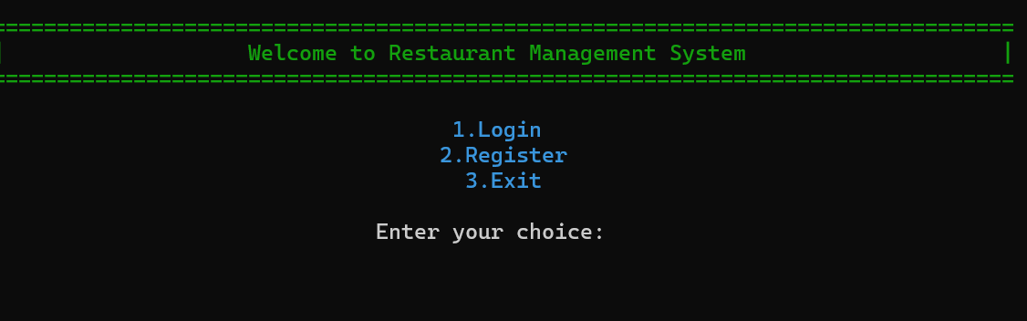

**Admin:**

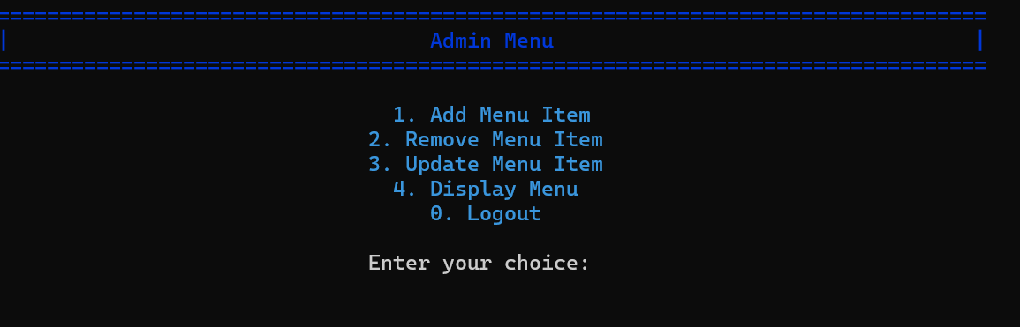

**Staff:**

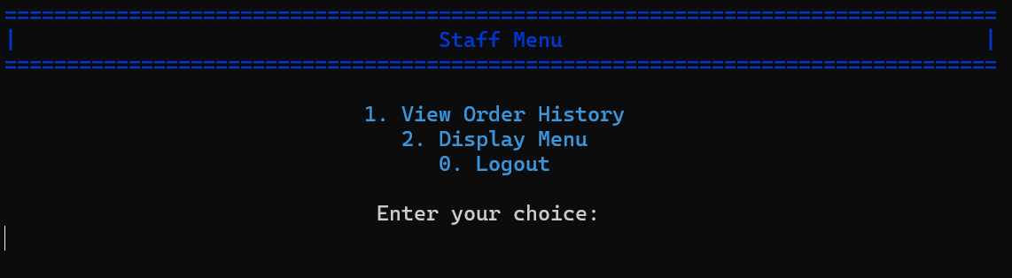

**Customer:**

